


《爬虫与数据分析》期末作业

题 目： | 爬虫综合成果展示、Django+Bootstrap+Apache项目部署
二级学院： | 数信学院
班 级： | 16计算机科学与技术四班
姓 名： | 陈星吉
学 号： | 16219111417
完成日期： | 2019-6-17

温州大学瓯江学院教务部
二○一二年十一月制

完成的工作：
- 静态爬虫，豆瓣TOP250电影爬取
- 静态爬虫，温州天气爬取
- 动态爬虫，京东华为手机相关数据前十页爬取
- 验证码登录，12306全自动登录
- Django+bootstrip，制作网站展示1~3爬取的数据
- 购买阿里云服务器，并使用apache部署django网站

相关网址、截图

1、阿里云服务器部署项目后的访问地址：
http://139.224.128.235/index/
在7月13号之前应该都能访问，因为我只买了一个月的服务器

网站截图：
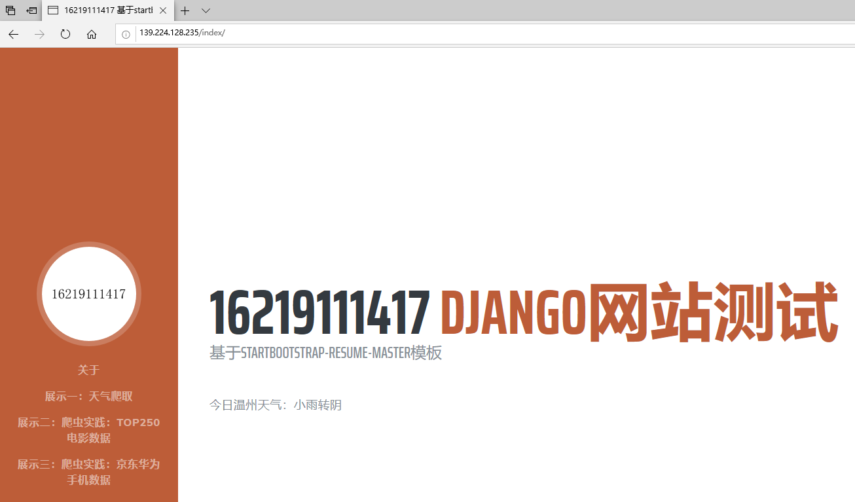
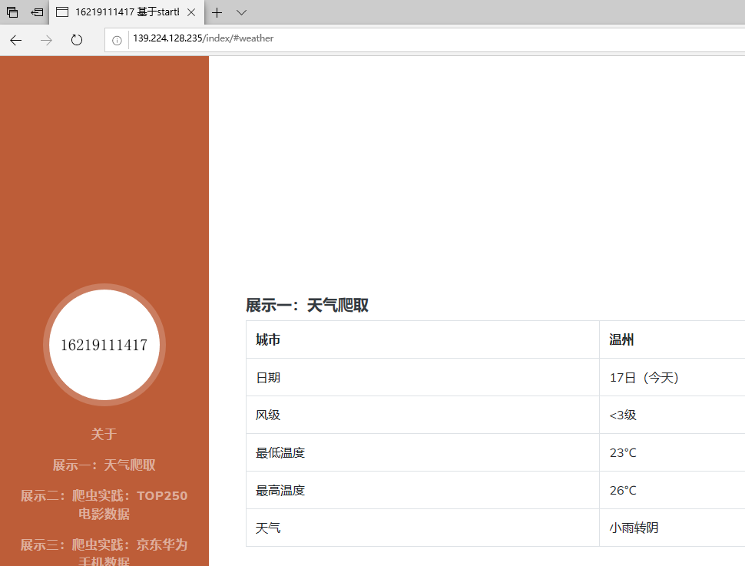
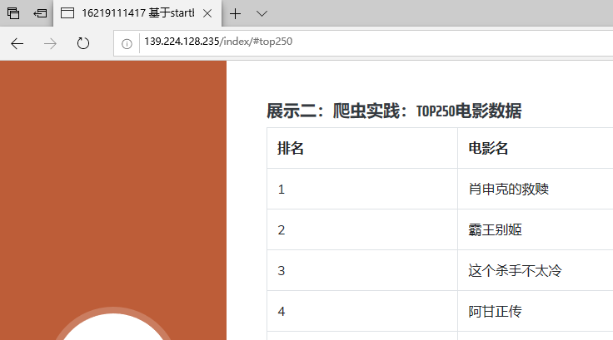
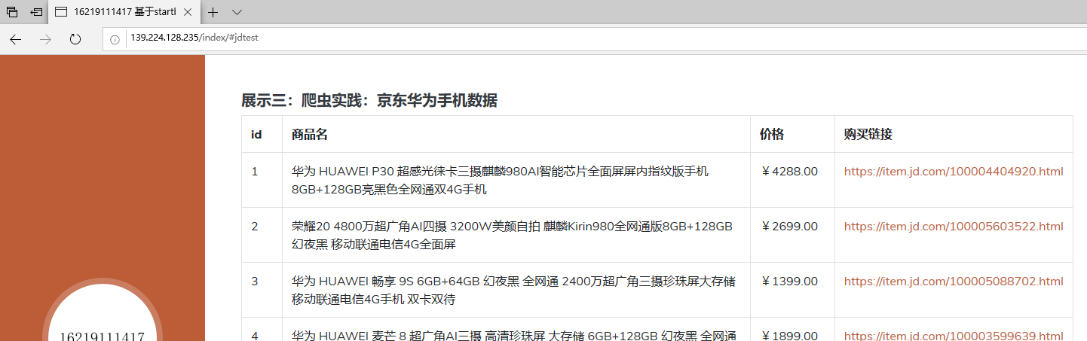

2、12306相关：
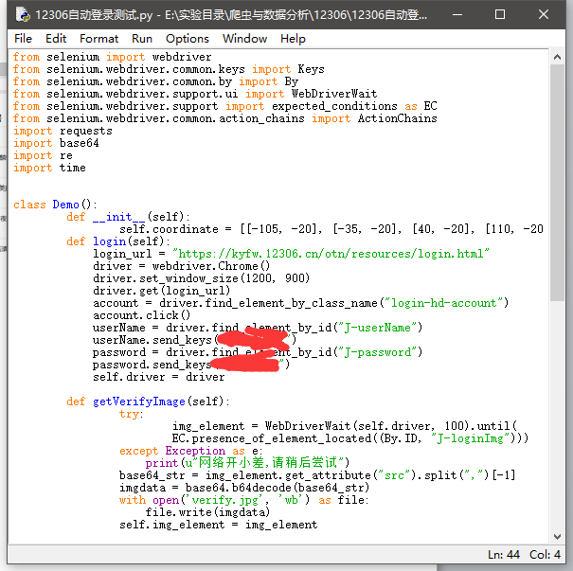
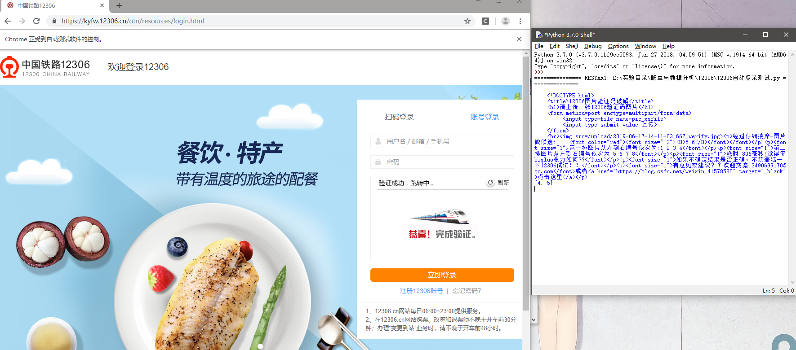

3、服务器相关截图：
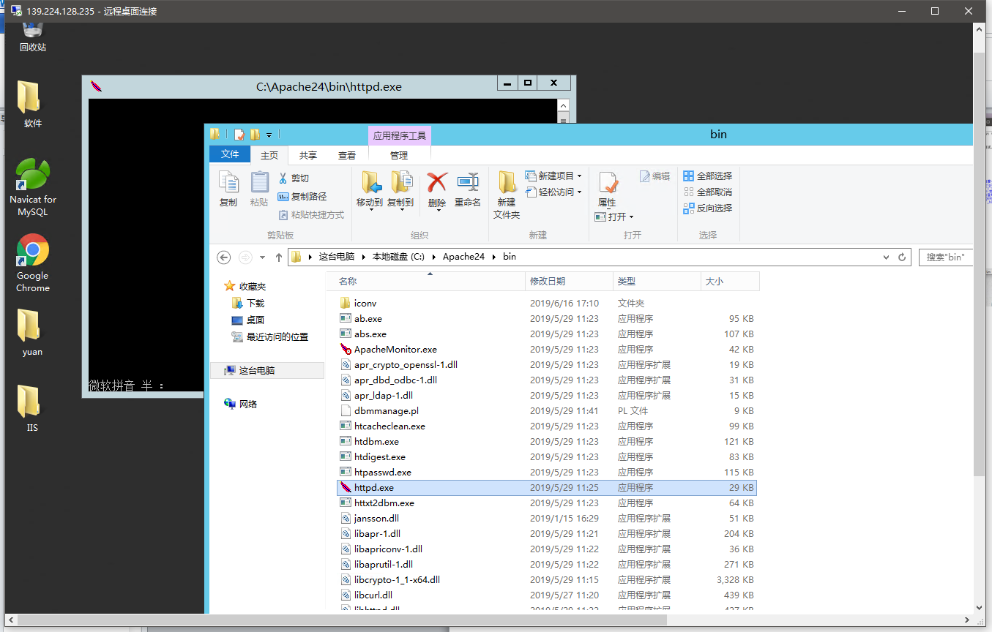
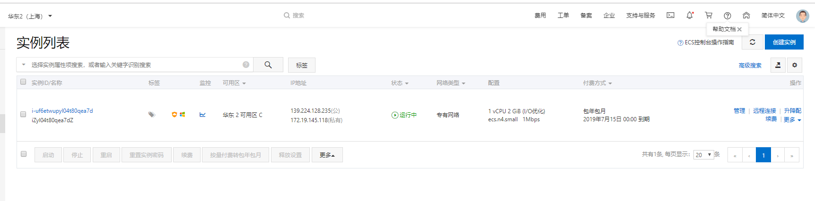

相关代码

服务器apache相关配置代码：
ServerName localhost:1919

LoadFile "C:\Users\Administrator\AppData\Local\Programs\Python\Python37\python3.dll"
LoadModule wsgi_module "C:\Users\Administrator\AppData\Local\Programs\Python\Python37\Lib\site-packages\mod_wsgi\server\mod_wsgi.cp37-win_amd64.pyd"
WSGIPythonHome "C:\Users\Administrator\AppData\Local\Programs\Python\Python37"

WSGIScriptAlias / C:\Users\Administrator\Desktop\yuan\mydjango\mydjango\wsgi.py

WSGIPythonPath C:\Users\Administrator\Desktop\yuan\mydjango

<Directory C:\Users\Administrator\Desktop\yuan\mydjango\mydjango>
<Files wsgi.py>
Require all granted
</Files>
</Directory>

Alias /static C:\Users\Administrator\Desktop\yuan\mydjango\static
<Directory C:\Users\Administrator\Desktop\yuan\mydjango>
Options FollowSymlinks
AllowOverride none
Require all granted
</Directory>

爬虫代码：

1、豆瓣：
#coding=UTF-8
import requests
from bs4 import BeautifulSoup
import MySQLdb

def get_movies():
headers = {
'user-agent':
'Mozilla/5.0 (Windows NT 6.1; Win64; x64) AppleWebKit/537.36 (KHTML, like Gecko) Chrome/52.0.2743.82 Safari/537.36',
'Host': 'movie.douban.com'
}
movie_list = []
for i in range(0, 10):
link = 'https://movie.douban.com/top250?start=' + str(i * 25)
r = requests.get(link, headers=headers, timeout=10)
print(str(i + 1), "页响应状态码:", r.status_code)

soup = BeautifulSoup(r.text, "lxml")
div_list = soup.find_all('div', class_='hd')
for each in div_list:
movie = each.a.span.text.strip()
movie_list.append(movie)
return movie_list

movies = get_movies()
conn = MySQLdb.connect(
host='localhost',
user='root',
passwd='123456',
db='mydjango',
charset='utf8')
cur = conn.cursor()
sqlClear = "TRUNCATE TABLE movie_dbtop250"
cur.execute(sqlClear)
for movie in movies:
cur.execute("INSERT INTO movie_dbtop250 (m_name) VALUES('" + movie + "')")
cur.close()
conn.commit()
conn.close()

2、天气爬虫：

from urllib.request import urlopen
from bs4 import BeautifulSoup
import re

resp=urlopen('http://www.weather.com.cn/weather/101270101.shtml')
soup=BeautifulSoup(resp,'html.parser')
tagDate=soup.find('ul', class_="t clearfix")
dates=tagDate.h1.string

tagToday=soup.find('p', class_="tem")
try:
temperatureHigh=tagToday.span.string
except AttributeError as e:
temperatureHigh=tagToday.find_next('p', class_="tem").span.string

temperatureLow=tagToday.i.string
weather=soup.find('p', class_="wea").string

tagWind=soup.find('p',class_="win")
winL=tagWind.i.string

print('今天是：'+dates)
print('风级：'+winL)
print('最低温度：'+temperatureLow)
print('最高温度：'+temperatureHigh)
print('天气：'+weather)

3、京东爬虫
from urllib import parse
import re
import time
from selenium import webdriver
import os
from lxml import etree
import MySQLdb

conn=MySQLdb.connect(host="localhost",user="root",passwd="123456",db="mydjango",charset="utf8")
cur=conn.cursor()
cur.execute("TRUNCATE TABLE jdtest")

#如果没有配置chromedriver.exe的环境变量，要写完整路径
chromedriver = "C:\Program Files (x86)\Google\Chrome\Application\chromedriver.exe"
#chromedriver = "chromedriver.exe"
browser = webdriver.Chrome(chromedriver)

url = "https://www.jd.com/"
browser.get(url)
time.sleep(1)
#手机号登录
phoneLogin = browser.find_element_by_xpath('//*[@id="key"]')
phoneLogin.send_keys('华为')

time.sleep(1)
# 搜索
#//*[@id="search"]/div/div[2]/button
btnNext = browser.find_element_by_xpath('//*[@id="search"]/div/div[2]/button')
btnNext.click()

def getitem(n):
time.sleep(3)
browser.execute_script("window.scrollTo(0, document.body.scrollHeight);") # 执行JavaScript实现网页下拉倒底部
page = browser.page_source
html = etree.HTML(page)
links = html.xpath("//*[@id='J_goodsList']/ul[@class='gl-warp clearfix']")
for link in links:
# 通过xpath获取商品链接
#//*[@id="J_goodsList"]/ul/li[5]/div/div[1]/a
verlink = link.xpath("./li[@class='gl-item']/div[@class='gl-i-wrap']/div[@class='p-img']/a/@href")
verlink = [parse.urljoin(browser.current_url,i) for i in verlink]
#通过xpath获取商品价格
#//*[@id="J_goodsList"]/ul/li[60]/div/div[3]/strong/i
price = link.xpath("./li[@class='gl-item']/div[@class='gl-i-wrap']/div[@class='p-price']/strong")
price = [item.xpath('string(.)') for item in price]
#通过xpath获取商品名称
#//*[@id="J_goodsList"]/ul/li[8]/div/div[4]/a/em
name=link.xpath("//div[@class='gl-i-wrap']/div[4]/a/em")
name = [item.xpath('string(.)') for item in name]
for i in range(len(verlink)-1):
Name=name[i]
Href=verlink[i]
Price=price[i]
print(Name)
cur.execute("insert into jdtest(name,href,price) values(\"%s\",\"%s\",\"%s\")"%(Name,Href,Price))

btnnext = browser.find_element_by_class_name("pn-next")
btnnext.click()

n=n+1
if n==10:
return
getitem(n)

getitem(0)
conn.commit()
conn.close()

4、12306自动登录
from selenium import webdriver
from selenium.webdriver.common.keys import Keys
from selenium.webdriver.common.by import By
from selenium.webdriver.support.ui import WebDriverWait
from selenium.webdriver.support import expected_conditions as EC
from selenium.webdriver.common.action_chains import ActionChains
import requests
import base64
import re
import time

class Demo():
def __init__(self):
self.coordinate = [[-105, -20], [-35, -20], [40, -20], [110, -20],[-105, 50], [-35, 50], [40, 50], [110, 50]]
def login(self):
login_url = "https://kyfw.12306.cn/otn/resources/login.html"
driver = webdriver.Chrome()
driver.set_window_size(1200, 900)
driver.get(login_url)
account = driver.find_element_by_class_name("login-hd-account")
account.click()
userName = driver.find_element_by_id("J-userName")
userName.send_keys("******")
password = driver.find_element_by_id("J-password")
password.send_keys("******")
self.driver = driver

def getVerifyImage(self):
try:
img_element = WebDriverWait(self.driver, 100).until(
EC.presence_of_element_located((By.ID, "J-loginImg")))
except Exception as e:
print(u"网络开小差,请稍后尝试")
base64_str = img_element.get_attribute("src").split(",")[-1]
imgdata = base64.b64decode(base64_str)
with open('verify.jpg', 'wb') as file:
file.write(imgdata)
self.img_element = img_element

def getVerifyResult(self):
url = "http://littlebigluo.qicp.net:47720/"
response = requests.request(
"POST",
url,
data={"type": "1"},
files={'pic_xxfile': open('verify.jpg', 'rb')})
result = []
print(response.text)
for i in re.findall("<B>(.*)</B>", response.text)[0].split(" "):
result.append(int(i) - 1)
self.result = result
print(result)

def moveAndClick(self):
try:
Action = ActionChains(self.driver)
for i in self.result:
Action.move_to_element(self.img_element).move_by_offset(self.coordinate[i][0], self.coordinate[i][1]).click()
Action.perform()
except Exception as e:
print(e.message())

def submit(self):
self.driver.find_element_by_id("J-login").click()

def __call__(self):
self.login()
time.sleep(3)
self.getVerifyImage()
time.sleep(1)
self.getVerifyResult()
time.sleep(1)
self.moveAndClick()
time.sleep(1)
self.submit()
time.sleep(10000)

Demo()()

后记
Github地址：https://github.com/cyc892012/16219111417qimopachong

主要是拿了期中已经写好的模板，大部分精力都花在研究如何在阿里云服务器上部署django网站了。
我购买的是windows server 2012 R2的系统，查了许多的资料，apache一开始配置失败后转用了IIS进行尝试，但依然失败。
后来严格更换了匹配的版本后重新配置apache，检查了配置的文件路径，终于能做到访问网站了，但一开始并没有加载静态文件，没有css和js，只有白板的网页。
在查阅了更多相关资料后，添加了对静态文件的配置，一开始依然不行，综合查阅了更多相关资料后，发现是路径配置有误，多打了一个“/”，删去后配置成功，网站访问时成功加载了静态文件。

